**Ripple Counter**

**Lab no #11**

** Fall 2019**

**Fall 2021**

**CSE202L Digital logic and computer design**

Submitted by: **Ashfaq Ahmad**

Registration No: **19PWCSE1795**

Class Section: **B**

“On my honor, as student of University of Engineering and Technology, I have neither given nor received unauthorized assistance on this academic work.”

Student Signature: ______________

Submitted to:

**Engr. Abdullah hameed**

February 24, 2021

**Department of Computer Systems Engineering**

**University of Engineering and Technology, Peshawar**

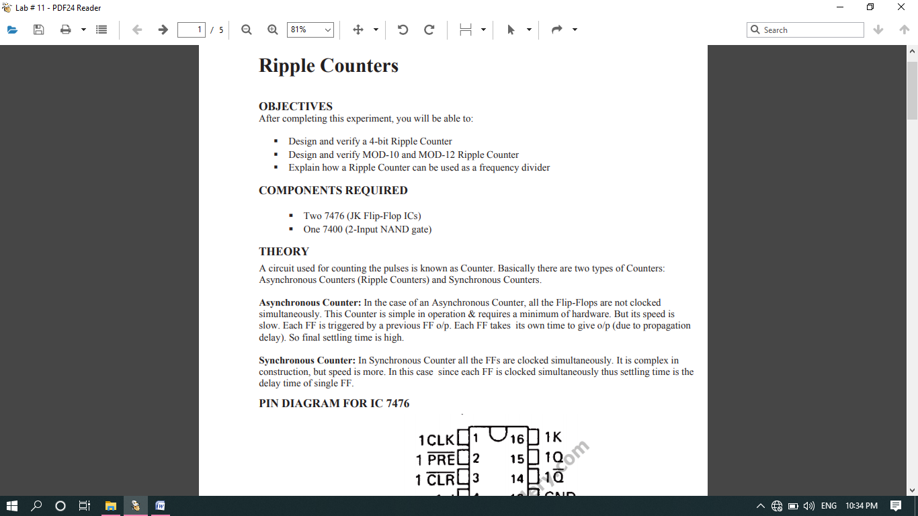

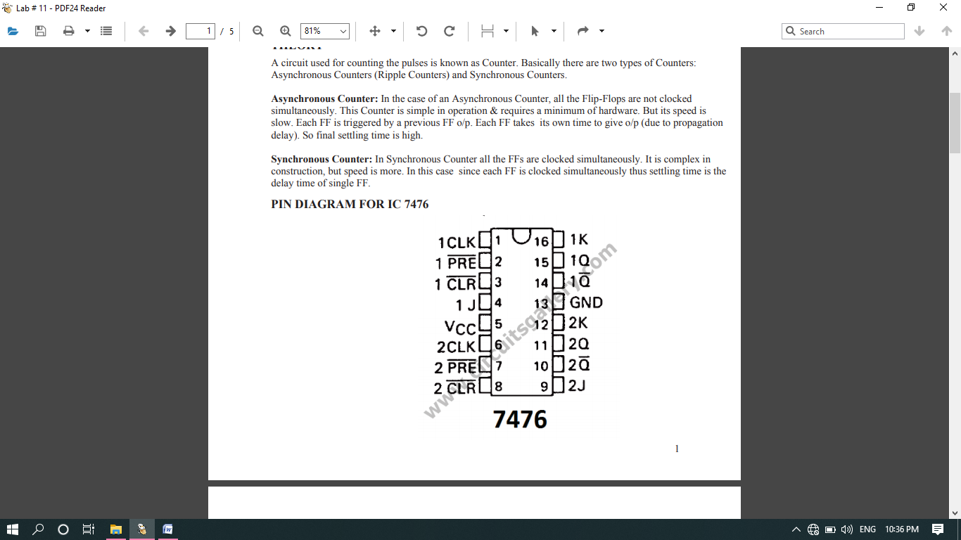

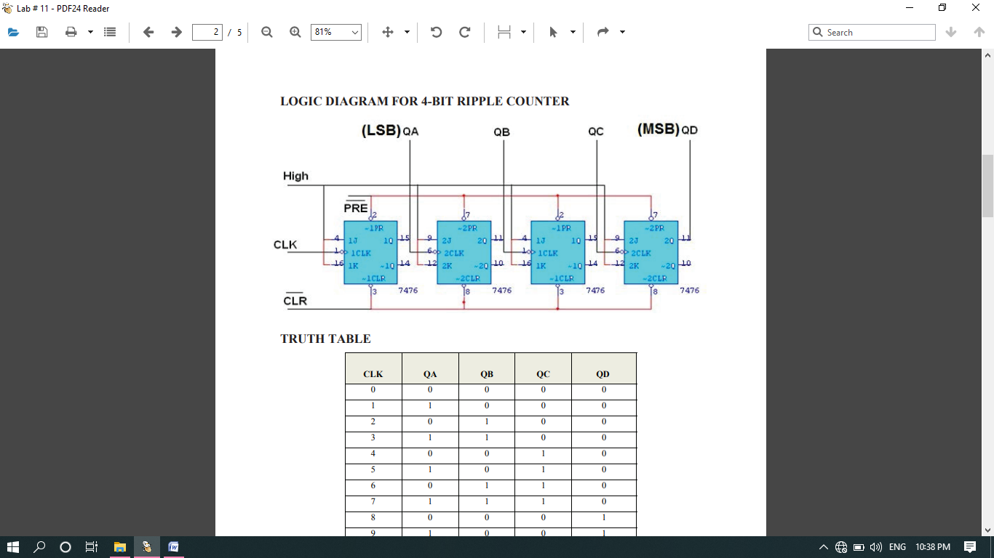

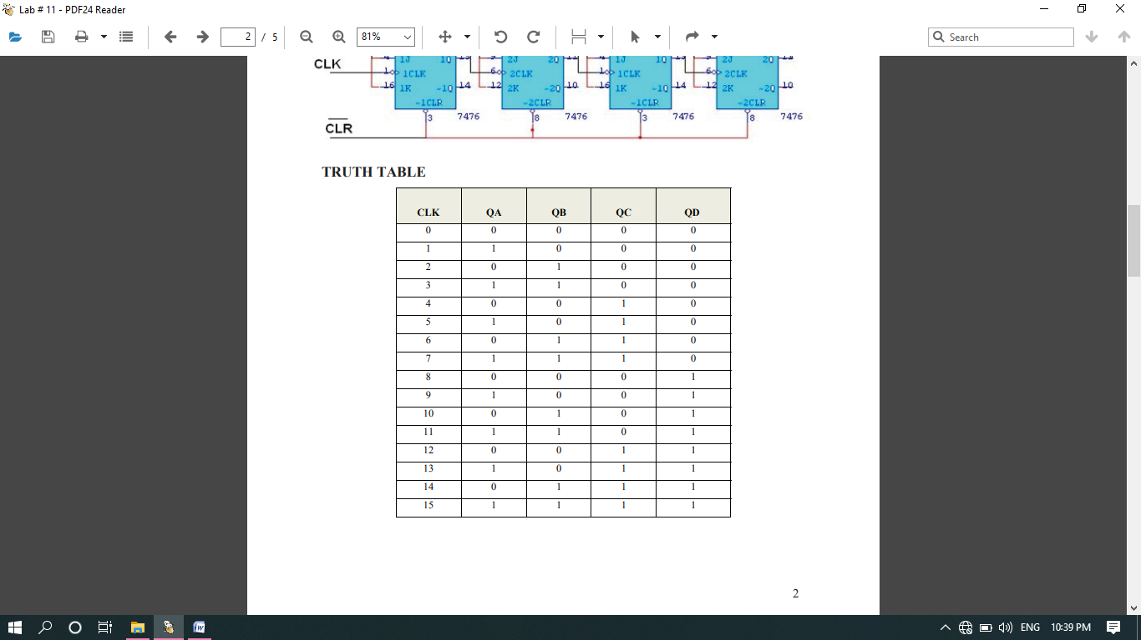

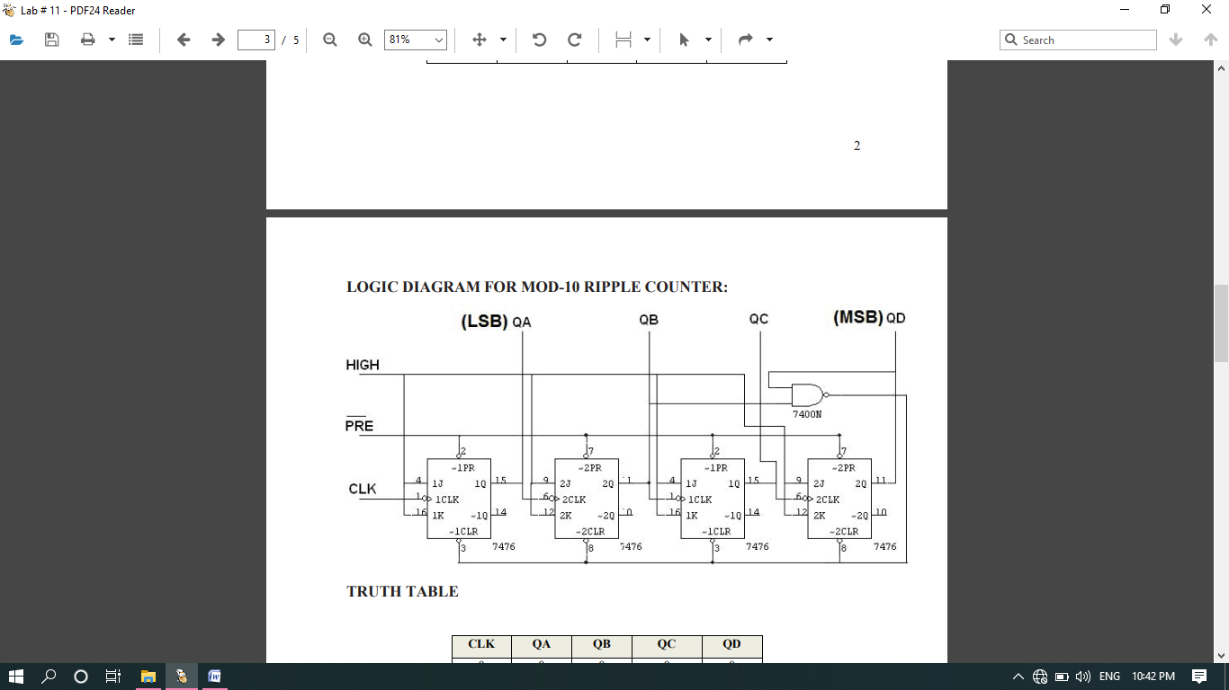

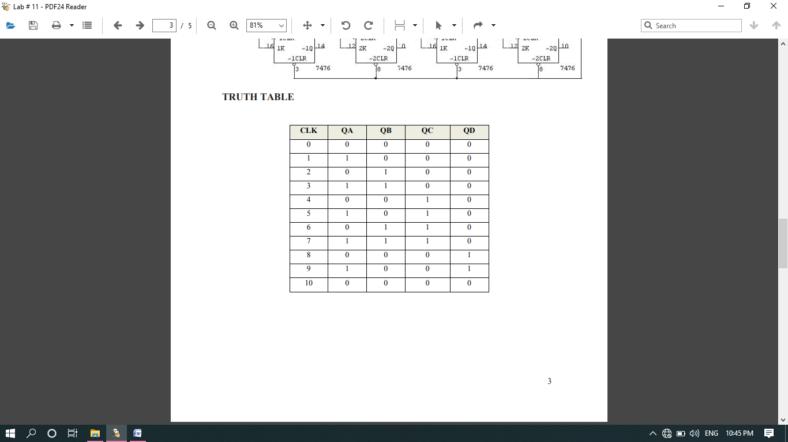

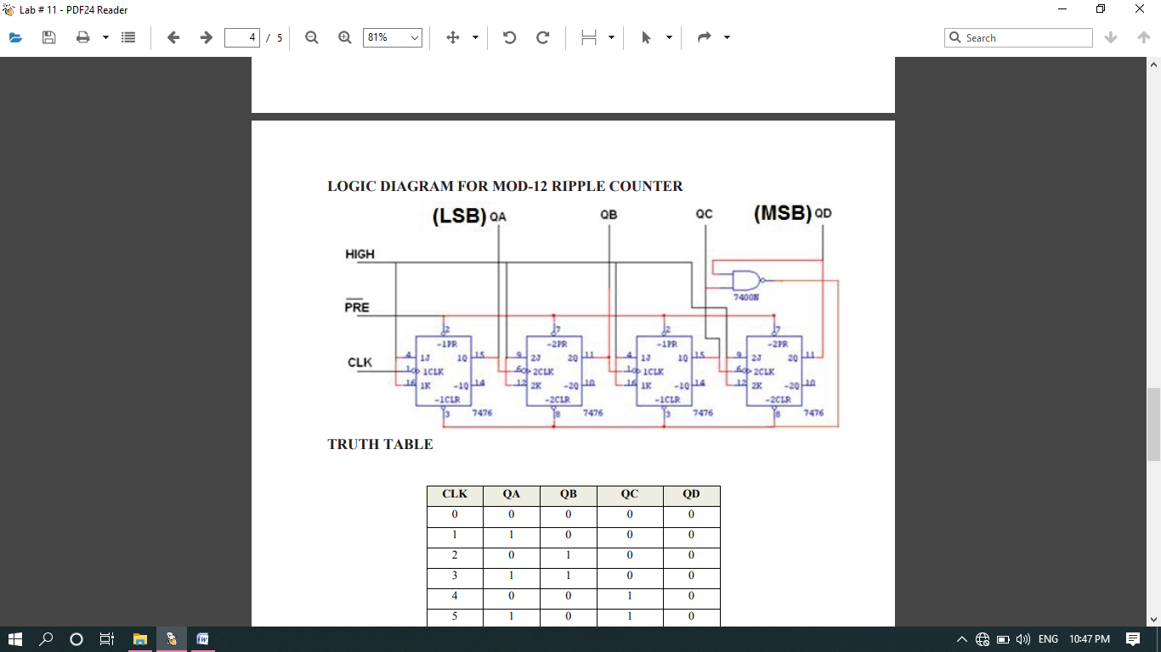  
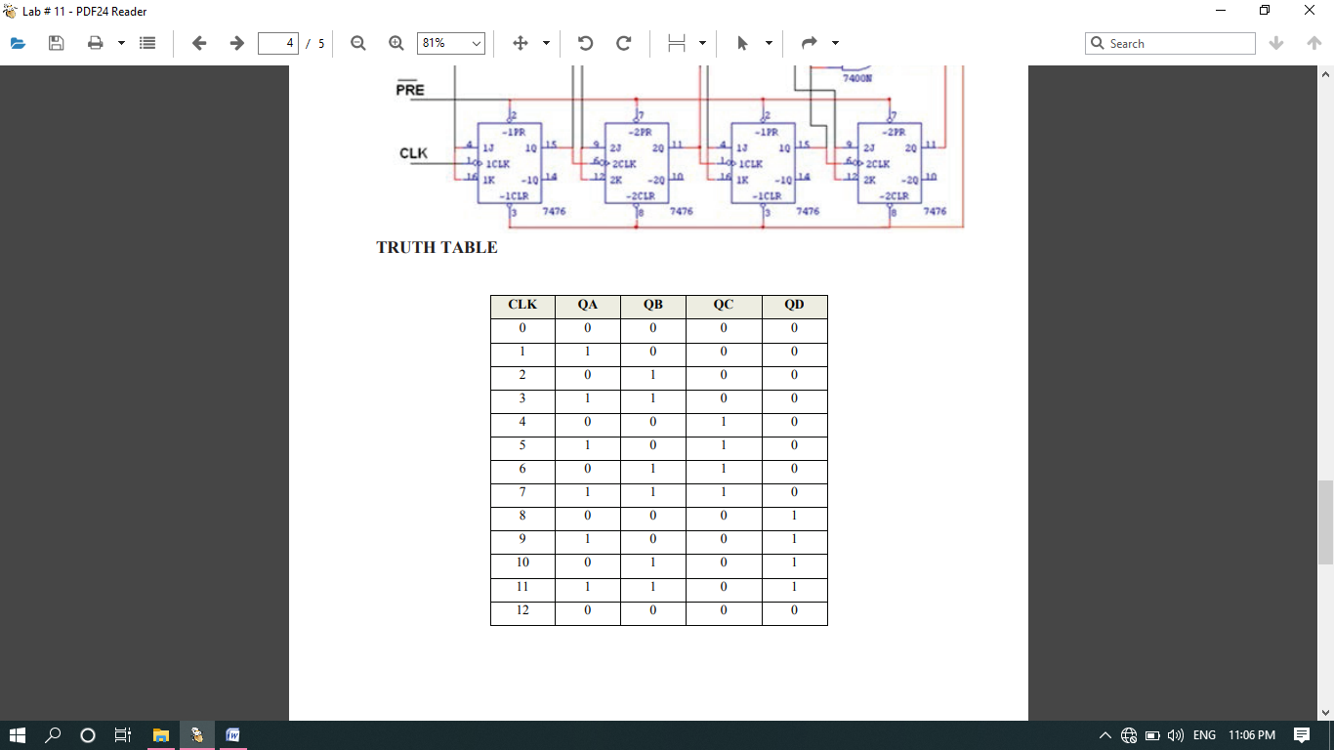

PROCEDUR:

Connections are given as per circuit diagram.

 Logical inputs are given as per circuit diagram.

 Observe the output and verify the truth table.

REVIEW QUESTIONS

1. Counters can be used as frequency dividers. When the clock frequency in the 4-bit ripple counter given above is 1 kHz , what would the output frequency of Flip Flop A and Flip Flop B?

Answer:

fA= __Half of the input frequency_______________________________

fB= __one fourth of the input frequency_______________________________

1. Would inverters on the clock inputs change the count direction of a 5 ripple counter?

Answer:

As synchronous counter circuit is dependent of the input clock so in case of synchronous inverter on clock input change the count direction of a 5 ripple counter while asynchronous is independent of the input clock so inverters on the clock inputs does not change the count direction of a 5 ripple counter.

1. How many Flip-Flops are needed to build a MOD-5 Counter?

Answer: 3 filp-flop needed to build a MOD-5 Counter.

***THE END***